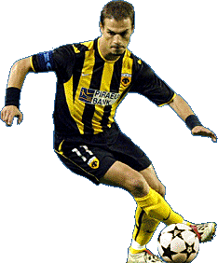Demis Nikolaides
Demis Nikolaides was born on September 17, 1983 in Giessen, in Germany to Greek parents. At the age of five, Demis and his family come back to Greece. Demis used to watch football with his cousin and both of them became fans of the famous A.E.K. team. Demis always wanted to be good enough to play with them. His favourite player, Thomas Mavros, played for AEK.
Demis started playing football for a team when he was 10 years old. Five years later he started training for the national team! In 1996 his dream came true, and he joined AEK. Other clubs wanted him to play for them and they offered him more money, but Demis said no. In 2003 Demis joined the Athletico football club in Madrid.
Demis married the well-known Greek singer, Despoina Vandi. In his spare time, he often reads or goes to the theatre. He’s never too busy to enjoy good music!
ΠΑΝΑΓΙΩΤΗΣ ΓΙΑΝΝΑΚΟΠΟΥΛΟΣ ΤΜΗΜΑ:Β1

